**DATE : 20/09/2021**

**ONLINE SHOPPING PROJECT**

BY

R.MAHESH KUMAR

ONLINE SHOPPING

**INTRODUCTION**

* The Name of the Project is ONLINE SHOPPING
* This Document Provides the details of the Project online Shopping
* The Purpose of the Project is to Provide easy Shopping facility online for the

Furniture

* This Website Provides the customer

**Project Properties**

1 . Netbeans 8.2

2 . HTML,CSS

3 . Java,Database

Login Page :

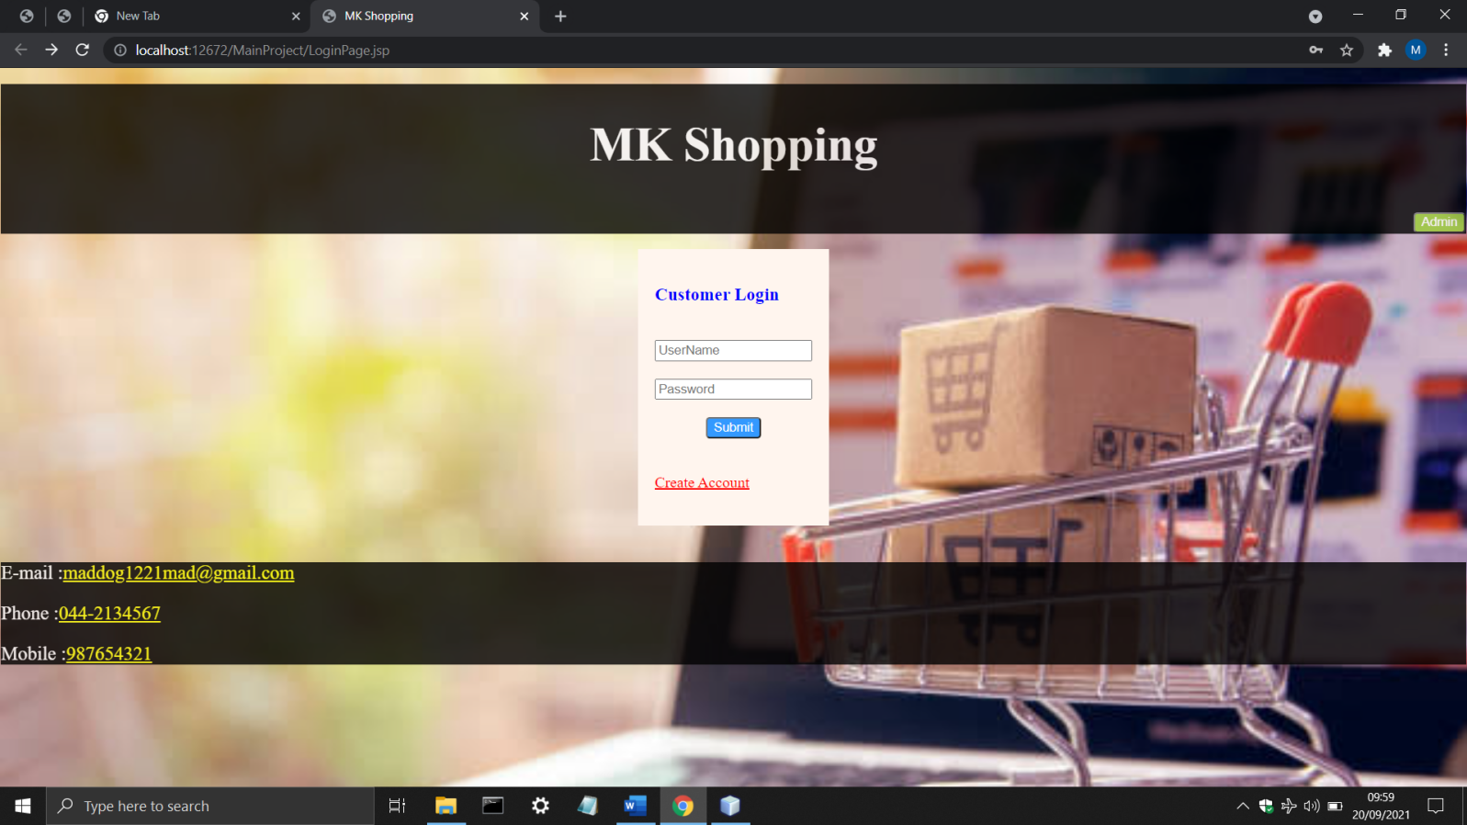

This Will be the Landing Page.

Create an Account If you’re a new customer By Clicking Create Account. After Clicking

You will be Redirected to Registration Page.

Registration Page :

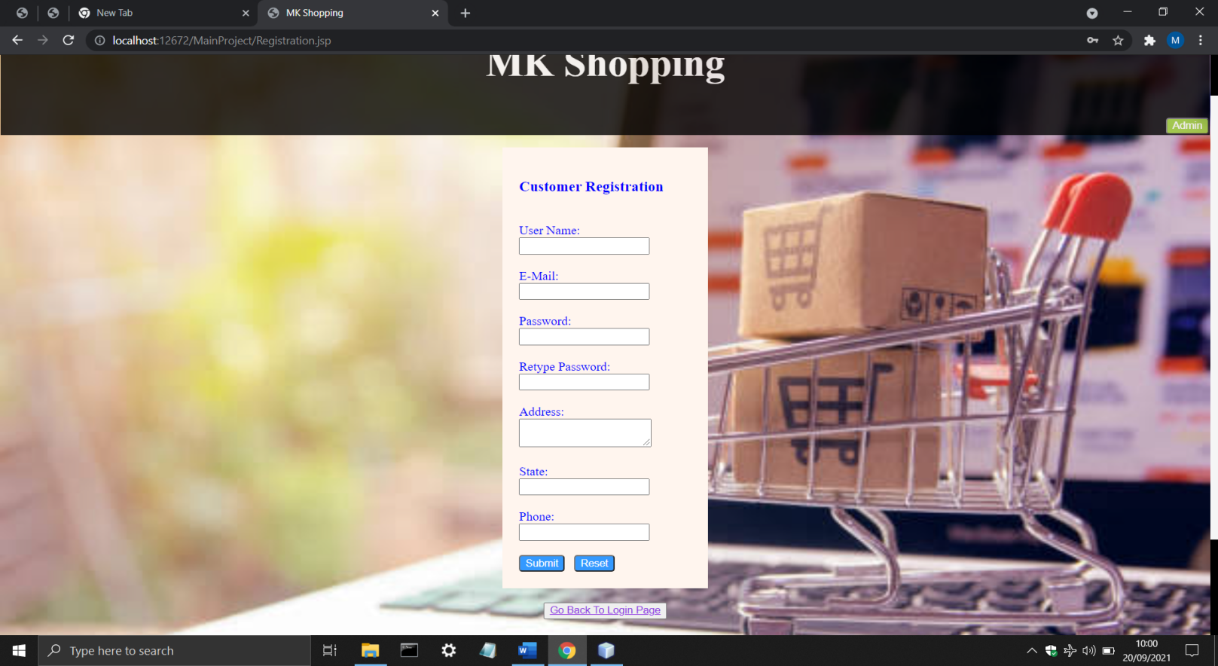

After Entering the Details Click Ok.

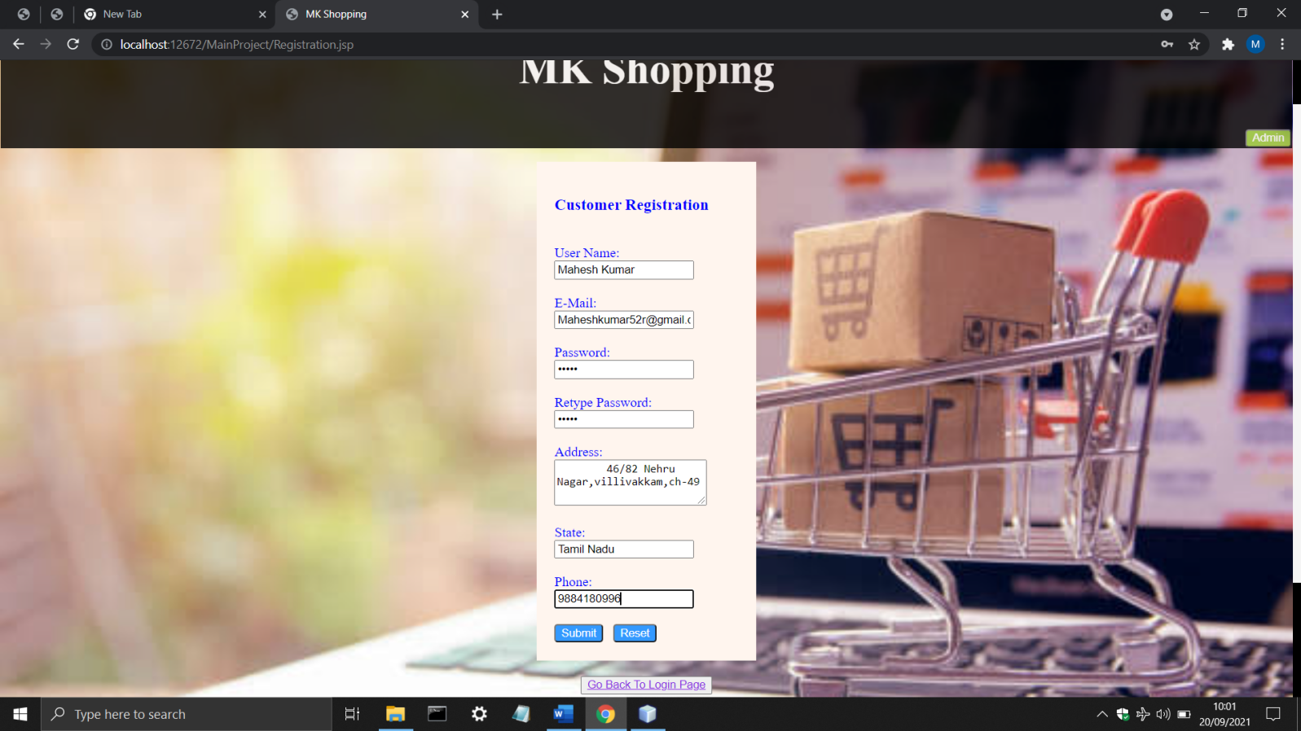

You Will be Redirected to Login Page If The details are Verified.Enter the User Name and Password

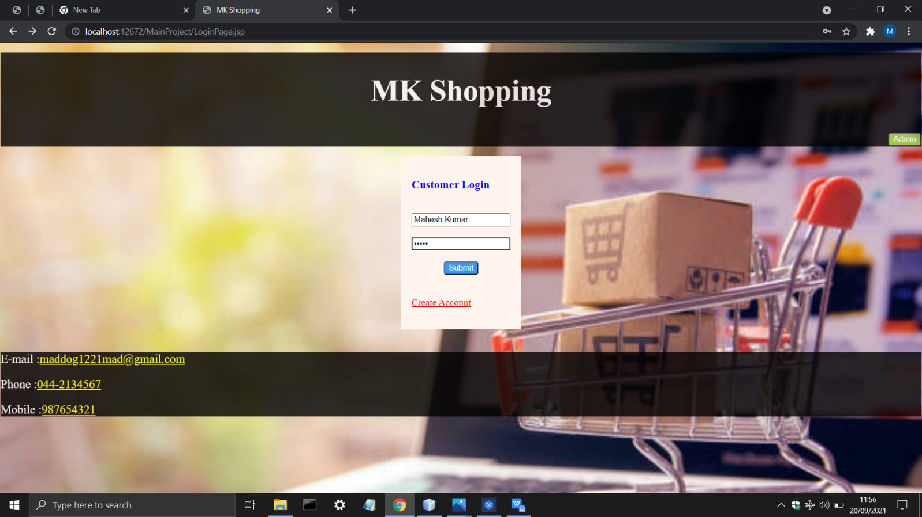

After Entering You will see This Page

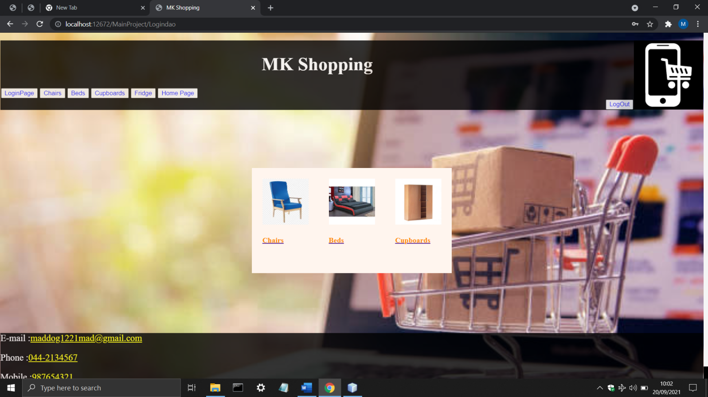

Click the Chairs

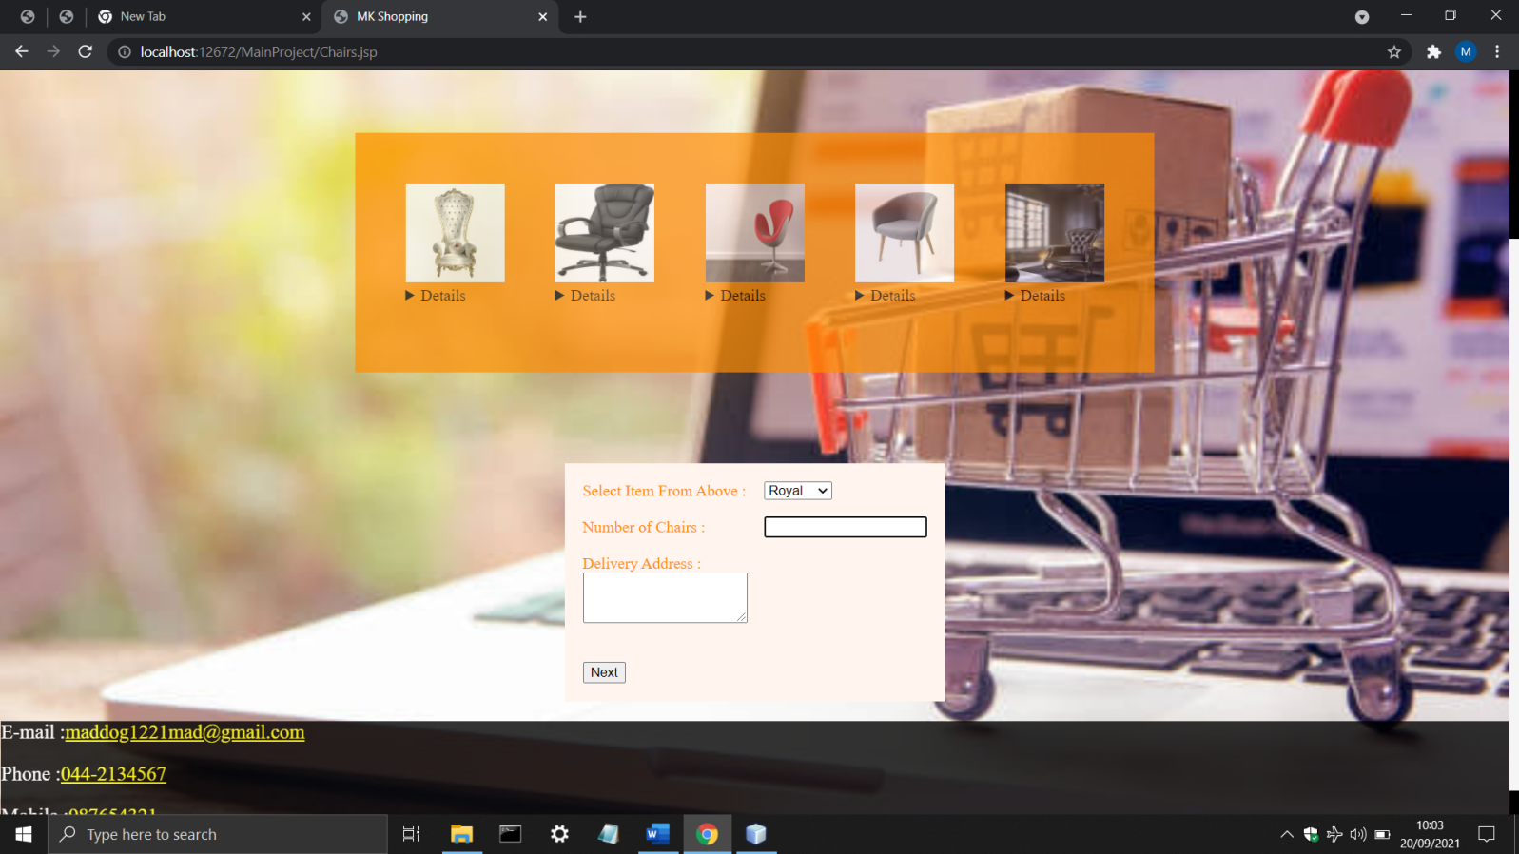

To view the details of the chair click on details. After that Select the Chair you want to buy

And enter number of Chairs, after that enter the Delivery Address.

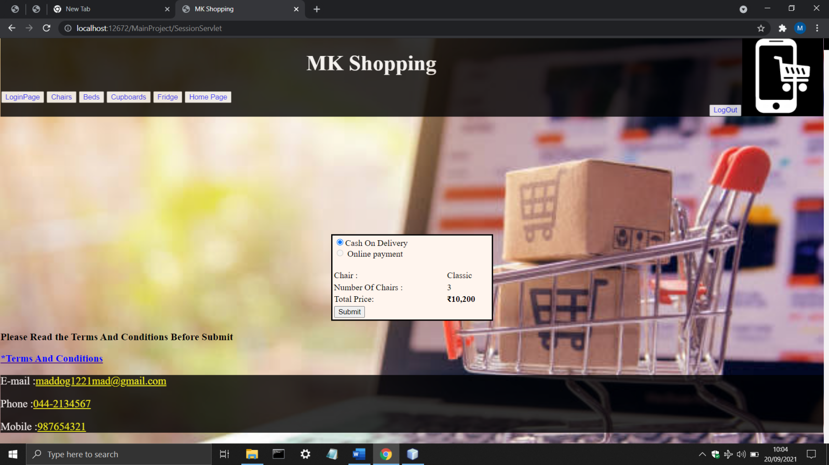

Verify The Details and Click On Submit Button to Place Order.

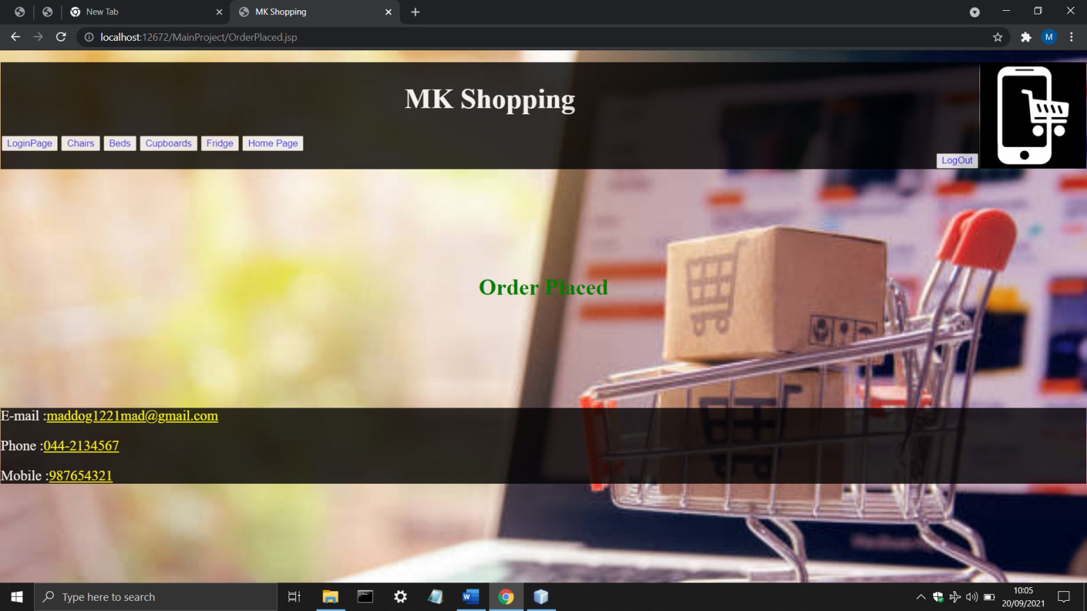

DataBase For Customer Registeration

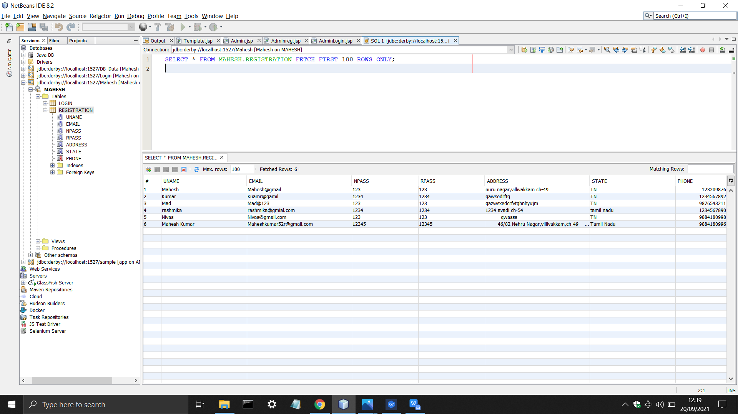

Header And Footer

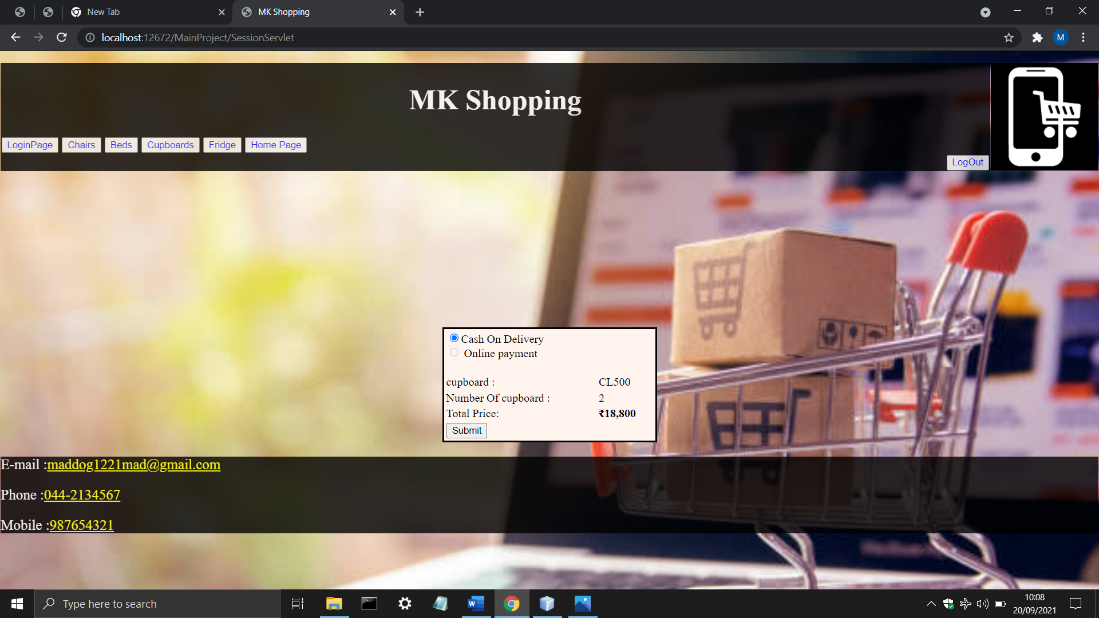

Footer



LoginPage.jsp

<%@page contentType="text/html" pageEncoding="UTF-8"%>

<!DOCTYPE html>

<html>

<jsp:include page="header1.jsp"></jsp:include>

<jsp:include page="Template.jsp"></jsp:include>

<head>

<meta http-equiv="Content-Type" content="text/html; charset=UTF-8">

<title>MK Shopping</title>

</head>

<body>

<center>

<form action="Logindao" method="POST">

<table style="border: solid seashell; border-spacing: 15px; opacity: 1; background-color: seashell">

<tr><td>

<h3 style="color: blue">Customer Login</h3><br>

<div align="right">

<input type="text" name="user" id="userid" value="" onkeyup="validate()" autofocus="" required="" placeholder="UserName"/><br/><br/>

<input type="password" name="pass" value="" required="" placeholder="Password"/><br/><br/></div>

<div align="center">

<input type="submit" value="Submit" style="background-color: #3399ff; color: white; border-radius: 4px"/>

</div><br><br>

<a href="Registration.jsp" style="color: red">Create Account</a><br/><br/>

</td></tr></table>

</form><br/>

</center>

</body>

<%@include file="footer.jsp"%>

</html>

Logindao.java

package control;

import java.io.IOException;

import java.io.PrintWriter;

import java.sql.Connection;

import java.sql.DriverManager;

import java.sql.PreparedStatement;

import java.sql.ResultSet;

import java.sql.SQLException;

import javax.servlet.RequestDispatcher;

import javax.servlet.ServletException;

import javax.servlet.annotation.WebServlet;

import javax.servlet.http.HttpServlet;

import javax.servlet.http.HttpServletRequest;

import javax.servlet.http.HttpServletResponse;

/**

*

* @author MAHESHKUMAR R

*/

@WebServlet(name = "Logindao", urlPatterns = {"/Logindao"})

public class Logindao extends HttpServlet {

protected void processRequest(HttpServletRequest request, HttpServletResponse response)

throws ServletException, IOException {

response.setContentType("text/html;charset=UTF-8");

try (PrintWriter out = response.getWriter()) {

}

}

@Override

protected void doPost(HttpServletRequest request, HttpServletResponse response)

throws ServletException, IOException {

PrintWriter out = response.getWriter();

String uname=request.getParameter("user");

String npass=request.getParameter("pass");

try{

Class.forName("org.apache.derby.jdbc.ClientDriver");

Connection con=DriverManager.getConnection("jdbc:derby://localhost:1527/Mahesh","Mahesh","12345");

System.out.println("connected using Login page");

String sql="select * from MAHESH.REGISTRATION where uname=? and npass=?";

PreparedStatement ps=con.prepareStatement(sql);

ps.setString(1, uname);

ps.setString(2, npass);

String unameDB="";

String npassDB="";

ResultSet rs=ps.executeQuery();

if(rs.next())

{

unameDB=rs.getString("uname");

npassDB=rs.getString("npass");

if((uname.equals(unameDB))&&(npass.equals(npassDB))){

RequestDispatcher rd=request.getRequestDispatcher("WelcomeCostumer.jsp");

rd.forward(request, response);

}

}

else{

RequestDispatcher rd=request.getRequestDispatcher("LoginPage.jsp");

out.println("<!DOCTYPE html>");

out.println("<html>");

out.println("<head>");

out.println("</head>");

out.println("<body>");

out.println("<center>");

out.println("<h2 style='color: red'>UserName Or Password Error</h2>");

out.println("</center>");

out.println("</body>");

out.println("</html>");

rd.include(request, response);

}

}catch(ClassNotFoundException | SQLException e){

System.out.println("Error From Login : "+e.getMessage());

}

}

Registration Page.jsp

<%@page contentType="text/html" pageEncoding="UTF-8"%>

<!DOCTYPE html>

<html>

<jsp:include page="header1.jsp"></jsp:include>

<jsp:include page="Template.jsp"></jsp:include>

<head>

<meta http-equiv="Content-Type" content="text/html; charset=UTF-8">

<title>MK Shopping</title>

</head>

<body>

<center>

<form action="registrationdao" method="post">

<table style="border: solid seashell; border-spacing: 18px; width: 17%; opacity: 1; background-color: seashell">

<tr><td>

<h3 style="color: blue">Customer Registration</h3><br>

<div style="color: blue">

User Name:<br><input type="text" name="username" value="" required="" autofocus=""/><br><br/>

E-Mail:<br/><input type="text" name="email" value="" required="" /><br/><br/>

Password:<br><input type="password" name="npass" value="" required=""/><br><br>

Retype Password:<br><input type="password" name="rpass" value="" required=""/><br><br>

Address:<br><textarea name="Address" rows="2" cols="20" required="">

</textarea><br><br>

State:<br><input type="text" name="State" value="" required=""/><br><br>

Phone:<br><input type="text" name="phone" value="" /><br><br>

</div>

<input type="submit" value="Submit" style="background-color: #3399ff; color: white; border-radius: 4px" />&nbsp;&nbsp;

<input type="reset" value="Reset" style="background-color: #3399ff; color: white; border-radius: 4px"/>

</td></tr>

</table>

</form>

<br>

<button style="color: gray"><a href="LoginPage.jsp" style="color: blueviolet">Go Back To Login Page</a></button>

</center>

<br><br>

</body>

<jsp:include page="footer.jsp"></jsp:include>

</html>

Registrationdao.java

package control;

import java.io.IOException;

import static java.lang.System.out;

import java.sql.Connection;

import java.sql.DriverManager;

import java.sql.PreparedStatement;

import java.sql.SQLException;

import javax.servlet.RequestDispatcher;

import javax.servlet.ServletException;

import javax.servlet.annotation.WebServlet;

import javax.servlet.http.HttpServlet;

import javax.servlet.http.HttpServletRequest;

import javax.servlet.http.HttpServletResponse;

/**

*

* @author MAHESHKUMAR R

*/

@WebServlet(name = "registrationdao", urlPatterns = {"/registrationdao"})

public class registrationdao extends HttpServlet {

protected void processRequest(HttpServletRequest request, HttpServletResponse response)

throws ServletException, IOException {

response.setContentType("text/html;charset=UTF-8");

// Statement st=null;

// String mg="";

String uname=request.getParameter("username");

String email=request.getParameter("email");

String npass=request.getParameter("npass");

String rpass=request.getParameter("rpass");

String address=request.getParameter("Address");

String state=request.getParameter("State");

String phone=request.getParameter("phone");

try {

Connection con;

Class.forName("org.apache.derby.jdbc.ClientDriver");

con=DriverManager.getConnection("jdbc:derby://localhost:1527/Mahesh","Mahesh","12345");

System.out.println("connected");

String sql = "insert into MAHESH.REGISTRATION(uname,email,npass,rpass,address,state,phone) values(?,?,?,?,?,?,?)";

PreparedStatement ps=con.prepareStatement(sql);

ps.setString(1, uname);

ps.setString(2, email);

ps.setString(3, npass);

ps.setString(4, rpass);

ps.setString(5, address);

ps.setString(6, state);

ps.setString(7, phone);

if(npass.equals(rpass))

{

ps.executeUpdate();

RequestDispatcher rds=request.getRequestDispatcher("LoginPage.jsp");

rds.forward(request, response);

}

else{

RequestDispatcher rds=request.getRequestDispatcher("Error.jsp");

rds.include(request, response);

}

}

catch(ClassNotFoundException | SQLException e){

out.println("Error in DB : "+e.getMessage());

}

}

@Override

protected void doGet(HttpServletRequest request, HttpServletResponse response)

throws ServletException, IOException {

processRequest(request, response);

}

@Override

protected void doPost(HttpServletRequest request, HttpServletResponse response)

throws ServletException, IOException {

processRequest(request, response);

}

@Override

public String getServletInfo() {

return "Short description";

}// </editor-fold>

}

WelcomeCustomer.jsp

<%@page contentType="text/html" pageEncoding="UTF-8"%>

<!DOCTYPE html>

<html>

<jsp:include page="header.jsp"></jsp:include>

<jsp:include page="Template.jsp"></jsp:include>

<head>

<meta http-equiv="Content-Type" content="text/html; charset=UTF-8">

<title>MK Shopping</title>

<style>

.nav{

list-style-type: none;

text-align: left;

margin: 0;

padding: 0;

}

.nav li{

display: inline-block;

padding: 20px;

}

</style>

</head>

<body>

<div align="center">

<table style="background-color: seashell"><tr><td>

<ul class="nav">

<li><a href="Chairs.jsp"><img src="Images/chair/Main.jpeg" width="100" height="100" alt="img 1"><br/><h4 style="color: darkorange">Chairs</h4></h4></a><br/></li>

<li><a href="Beds.jsp"><img src="Images/bed/Main.jpeg" width="100" height="100" alt="img 2"><br/><h4 style="color: darkorange">Beds</h4></a><br/></li>

<li><a href="Cupboards.jsp"><img src="Images/cupboard/Main.jpeg" width="100" height="100" alt="img 3"><br/><h4 style="color: darkorange">Cupboards</h4></a><br/></li>

<%-- <li><a href="Fridge.jsp"><img src="Images/fridge/Main.jpeg" width="100" height="100" alt="img 4"><br/><h4 style="color: darkorange">Fridge</h4></a><br/></li> --%>

</ul>

</td></tr></table>

</div>

</body>

<br><br><br><br><br><br>

<jsp:include page="footer.jsp"></jsp:include>

</html>

Chairs.jsp

<%@page contentType="text/html" pageEncoding="UTF-8"%>

<%@taglib prefix="c" uri="http://java.sun.com/jsp/jstl/core"%>

<!DOCTYPE html>

<html>

<jsp:include page="header.jsp"></jsp:include>

<jsp:include page="Template.jsp"></jsp:include>

<head>

<meta http-equiv="Content-Type" content="text/html; charset=UTF-8">

<title>MK Shopping</title>

</head>

<body>

<center>

<form action='<c:url value="/SessionServlet"/>' name="myform" method="post">

<table style="border: none; border-spacing: 50px; background-color: darkorange; opacity: 0.7"><tr>

<td><img src='Images/chair/1.jpeg' name="chair" value="Royal" width='100' height='100'/>

<details><c:set var="Royal" value="1400"/>Price : <c:out value="${Royal}"/><br>

<c:set var="Royal" value="Royal"/>Name : <c:out value="${Royal}"/></details><br/></td>

<td><img src='Images/chair/2.jpeg' name="chair" value="Office" width='100' height='100' />

<details><c:set var="Office" value="1200"/>Price : <c:out value="${Office}"/><br>

<c:set var="Office" value="Office"/>Name : <c:out value="${Office}"/></details><br/></td>

<td><img src='Images/chair/3.jpeg' name="chair" value="Red" width='100' height='100'/>

<details><c:set var="Red" value="3000"/>Price : <c:out value="${Red}"/><br>

<c:set var="Red" value="Red"/>Name : <c:out value="${Red}"/></details><br/></td>

<td><img src='Images/chair/4.jpeg' name="chair" value="Classic" width='100' height='100'/>

<details><c:set var="Classic" value="3400"/>Price : <c:out value="${Classic}"/><br>

<c:set var="Classic" value="Classic"/>Name : <c:out value="${Classic}"/></details><br/></td>

<td><img src='Images/chair/5.jpeg' name="chair" value="Modern" width='100' height='100'/>

<details><c:set var="Modern" value="5400"/>Price : <c:out value="${Modern}"/><br>

<c:set var="Modern" value="Modern"/>Name : <c:out value="${Modern}"/></details><br/></td>

</tr></table></form>

<br><br><br><br><br>

<form action='<c:url value="/SessionServlet"/>' name='MyForm' method='POST'>

<table style="border: solid seashell; border-spacing: 15px; opacity: 1; background-color: seashell"> <tr>

<td bordercolor='white'><font color='darkorange'> Select Item From Above : </font></td>

<td bordercolor='white'>

<select name='chair'>

<option value='Royal'>Royal</option>

<option value='Office'>Office</option>

<option value='Red'>Red</option>

<option value='Classic'>Classic</option>

<option value='Modern'>Modern</option>

</select>

<tr>

<td bordercolor='white'><font color='darkorange'> Number of Chairs : </font> </td>

<td bordercolor='white'>

<input type= 'text' name='numOfchairs' required="" autofocus=""></td> </tr> <tr><td allign="center">

<font color='darkorange'>Delivery Address : </font><br><textarea name="Delivery Address" rows="3" cols="20" required=""></textarea><br/><br/>

<input type='hidden' value='ychair' name='PageName'/> </td> </tr> <tr>

<td bordercolor='white'>

<input type='submit' Value='Next'></input></td>

</tr></table></form>

</center>

</body>

<jsp:include page="footer.jsp"></jsp:include>

</html>

SessionServlet.java

package control;

import java.io.IOException;

import java.io.PrintWriter;

import javax.servlet.RequestDispatcher;

import javax.servlet.ServletException;

import javax.servlet.annotation.WebServlet;

import javax.servlet.http.HttpServlet;

import javax.servlet.http.HttpServletRequest;

import javax.servlet.http.HttpServletResponse;

import javax.servlet.http.HttpSession;

/**

*

* @author MAHESHKUMAR R

*/

@WebServlet(name = "SessionServlet", urlPatterns = {"/SessionServlet"})

public class SessionServlet extends HttpServlet {

protected void processRequest(HttpServletRequest request, HttpServletResponse response)

throws ServletException, IOException {

response.setContentType("text/html;charset=UTF-8");

try (PrintWriter out = response.getWriter()) {

HttpSession session = request.getSession(false);

String requestingPageName = request.getParameter("PageName");

switch (requestingPageName) {

case "ychair":

{

String selectedChair = request.getParameter("chair");

String noOfchairs = request.getParameter("numOfchairs");

session.setAttribute("selChair", selectedChair);

session.setAttribute("numchairs", noOfchairs);

RequestDispatcher dispatch = request.getRequestDispatcher("details.jsp");

dispatch.forward(request, response);

break;

}

case "ybed":

{

String selectedbed = request.getParameter("bed");

String noOfbed = request.getParameter("numOfBed");

session.setAttribute("selbed", selectedbed);

session.setAttribute("numbed", noOfbed);

RequestDispatcher dispatch = request.getRequestDispatcher("Beddetails.jsp");

dispatch.forward(request, response);

break;

}

case "ycupboard":

{

String selectedcupboard = request.getParameter("cupboard");

String noOfcupboard = request.getParameter("numOfcupboard");

session.setAttribute("selcupboard", selectedcupboard);

session.setAttribute("numcupboard", noOfcupboard);

RequestDispatcher dispatch = request.getRequestDispatcher("cupboarddetails.jsp");

dispatch.forward(request, response);

break;

}

default:

{

RequestDispatcher dispatch = request.getRequestDispatcher("Error.jsp");

dispatch.forward(request, response);

break;

}

}

}

}

@Override

protected void doGet(HttpServletRequest request, HttpServletResponse response)

throws ServletException, IOException {

processRequest(request, response);

}

@Override

protected void doPost(HttpServletRequest request, HttpServletResponse response)

throws ServletException, IOException {

processRequest(request, response);

}

@Override

public String getServletInfo() {

return "Short description";

}// </editor-fold>

}

Details.jsp

<%@taglib prefix="c" uri="http://java.sun.com/jsp/jstl/core" %>

<%@page contentType="text/html" pageEncoding="UTF-8"%>

<%@taglib prefix="fmt" uri="http://java.sun.com/jsp/jstl/fmt" %>

<!DOCTYPE html>

<html>

<jsp:include page="header.jsp"></jsp:include>

<jsp:include page="Template.jsp"></jsp:include>

<head>

<meta http-equiv="Content-Type" content="text/html; charset=UTF-8">

<title>details</title>

</head>

<body>

<center>

<form action="OrderPlaced.jsp" method="post">

<table style="color: black; border: 3px solid; width: 300px; height: 160px; background-color: seashell" ><tr><td>

<input type="radio" name="bt" value="cash" checked="checked" />Cash On Delivery<br>

<input type="radio" name="bt" value="online" disabled="disabled" /> Online payment<br/><br/>

</td></tr>

<c:set var="chair" value="${sessionScope.selChair}"/>

<c:set var="NumberOfchairs" value="${numchairs}"/>

<c:choose>

<c:when test="${chair=='Royal'}">

<c:set var="Price" value="1400"/>

</c:when>

<c:when test="${chair=='Office'}">

<c:set var="Price" value="1200"/>

</c:when>

<c:when test="${chair=='Red'}">

<c:set var="Price" value="3000"/>

</c:when>

<c:when test="${chair=='Classic'}">

<c:set var="Price" value="3400"/>

</c:when>

<c:when test="${chair=='Modern'}">

<c:set var="Price" value="5400"/>

</c:when>

</c:choose>

<tr><td bordercolor='white'>Chair : <td colspan="2"><c:out value="${chair}"/> </td><br>

<br>

<tr><td bordercolor='Black'>Number Of Chairs : <td colspan="2"><c:out value="${NumberOfchairs}"/></td> <br>

<tr><td bordercolor='Black'>Total Price: <td colspan="2"><b><fmt:formatNumber pattern="₹##,##,###.##" value="${Price*NumberOfchairs}"/></b></td><br><br/>

<tr>

<td><input type="submit" value="Submit" /></td></tr>

</table>

</form>

</center>

<h3>Please Read the Terms And Conditions Before Submit</h3>

<a href="Terms.jsp"><h3 style="color: blue">*Terms And Conditions</h3></a>

</body>

<jsp:include page="footer.jsp"></jsp:include>

</html>

OrderPlaced.jsp

<%@page contentType="text/html" pageEncoding="UTF-8"%>

<!DOCTYPE html>

<html>

<jsp:include page="header.jsp"></jsp:include>

<jsp:include page="Template.jsp"></jsp:include>

<head>

<meta http-equiv="Content-Type" content="text/html; charset=UTF-8">

<title>JSP Page</title>

</head>

<body>

<center>

<h1 style="color: green">Order Placed</h1>

</center>

</body>

<br><br><br><br><br><br>

<jsp:include page="footer.jsp"></jsp:include>

</html>

Bed.jsp

<%@page contentType="text/html" pageEncoding="UTF-8"%>

<%@taglib prefix="c" uri="http://java.sun.com/jsp/jstl/core"%>

<!DOCTYPE html>

<html>

<jsp:include page="header.jsp"></jsp:include>

<jsp:include page="Template.jsp"></jsp:include>

<head>

<meta http-equiv="Content-Type" content="text/html; charset=UTF-8">

<title>MK Shopping</title>

</head>

<body>

<center>

<form action='<c:url value="/SessionServlet"/>' name="myform" method="post">

<table style="border: none; border-spacing: 50px; background-color: whitesmoke; opacity: 0.8"><tr>

<td><img src='Images/bed/1.jpeg' name="bed" value="Cotton" width='100' height='100'/>

<details><c:set var="Cotton" value="11000"/>Price : <c:out value="${Cotton}"/><br>

<c:set var="Cotton" value="Cotton"/>Name : <c:out value="${Cotton}"/></details><br/></td>

<td><img src='Images/bed/2.jpeg' name="bed" value="Coffee" width='100' height='100' />

<details><c:set var="Coffee" value="12000"/>Price : <c:out value="${Coffee}"/><br>

<c:set var="Coffee" value="Coffee"/>Name : <c:out value="${Coffee}"/></details><br/></td>

<td><img src='Images/bed/3.jpeg' name="bed" value="Trundle" width='100' height='100'/>

<details><c:set var="Trundle" value="13000"/>Price : <c:out value="${Trundle}"/><br>

<c:set var="Trundle" value="Trundle"/>Name : <c:out value="${Trundle}"/></details><br/></td>

<td><img src='Images/bed/4.jpeg' name="bed" value="RedTrundle" width='100' height='100'/>

<details><c:set var="RedTrundle" value="17000"/>Price : <c:out value="${RedTrundle}"/><br>

<c:set var="RedTrundle" value="Red Trundle"/>Name : <c:out value="${RedTrundle}"/></details><br/></td>

<td><img src='Images/bed/5.jpeg' name="bed" value="Headboard" width='100' height='100'/>

<details><c:set var="Headboard" value="9000"/>Price : <c:out value="${Headboard}"/><br>

<c:set var="Headboard" value="Headboard"/>Name : <c:out value="${Headboard}"/></details><br/></td>

<td><img src='Images/bed/6.jpeg' name="bed" value="waterbed" width='100' height='100'/>

<details><c:set var="Waterbed" value="7000"/>Price : <c:out value="${Waterbed}"/><br>

<c:set var="waterbed" value="water bed"/>Name : <c:out value="${waterbed}"/></details><br/></td>

</tr></table></form>

<br><br><br><br><br>

<form action='<c:url value="/SessionServlet"/>' name='MyForm' method='POST'>

<table style="border: solid seashell; border-spacing: 15px; opacity: 1; background-color: seashell"> <tr>

<td bordercolor='white'><font color='darkblue'> Select Item From Above : </font></td>

<td bordercolor='white'>

<select name='bed'>

<option value='Cotton'>Cotton</option>

<option value='Coffee'>Coffee</option>

<option value='Trundle'>Trundle</option>

<option value='RedTrundle'>Red Trundle</option>

<option value='Headboard'>Headboard</option>

<option value='waterbed'>water bed</option>

</select>

<tr>

<td bordercolor='white'>Number of bed </td>

<td bordercolor='white'>

<input type= 'text' name='numOfBed' required="" autofocus=""></td> </tr> <tr><td allign="center">

Delivery Address : <br><textarea name="Delivery Address" rows="3" cols="20" required=""></textarea><br/><br/>

<input type='hidden' value='ybed' name='PageName'/> </td> </tr> <tr>

<td bordercolor='white'>

<input type='submit' Value='Next'></input></td>

</tr></table></form>

</center>

</body>

<jsp:include page="footer.jsp"></jsp:include>

</html>

Beddetails.jsp

<%@page contentType="text/html" pageEncoding="UTF-8"%>

<%@taglib prefix="c" uri="http://java.sun.com/jsp/jstl/core"%>

<%@taglib prefix="fmt" uri="http://java.sun.com/jsp/jstl/fmt" %>

<!DOCTYPE html>

<html>

<jsp:include page="header.jsp"></jsp:include>

<jsp:include page="Template.jsp"></jsp:include>

<head>

<meta http-equiv="Content-Type" content="text/html; charset=UTF-8">

<title>JSP Page</title>

</head>

<body>

<center>

<form action="OrderPlaced.jsp" method="post">

<table style="color: black; border: 3px solid; width: 300px; height: 160px; background-color: seashell" ><tr><td>

<input type="radio" name="bt" value="cash" checked="checked" />Cash On Delivery<br>

<input type="radio" name="bt" value="online" disabled="disabled" /> Online payment<br/><br/>

</td></tr>

<c:set var="bed" value="${sessionScope.selbed}"/>

<c:set var="NumberOfBed" value="${numbed}"/>

<c:choose>

<c:when test="${bed=='Cotton'}">

<c:set var="Price" value="11000"/>

</c:when>

<c:when test="${bed=='Coffee'}">

<c:set var="Price" value="12000"/>

</c:when>

<c:when test="${bed=='Trundle'}">

<c:set var="Price" value="13000"/>

</c:when>

<c:when test="${bed=='RedTrundle'}">

<c:set var="Price" value="17000"/>

</c:when>

<c:when test="${bed=='Headboard'}">

<c:set var="Price" value="9000"/>

</c:when>

<c:when test="${bed=='waterbed'}">

<c:set var="Price" value="7000"/>

</c:when>

</c:choose>

<tr><td bordercolor='white'>BED : <td colspan="2"><c:out value="${bed}"/> </td><br>

<br>

<tr><td bordercolor='Black'>Number Of Beds : <td colspan="2"><c:out value="${NumberOfBed}"/></td> <br>

<tr><td bordercolor='Black'>Total Price: <td colspan="2"><b><fmt:formatNumber pattern="₹##,##,###.##" value="${Price*NumberOfBed}"/></b></td><br><br/>

<tr>

<td><input type="submit" value="Submit" /></td></tr>

</table>

</form>

</center>

<h3>Please Read the Terms And Conditions Before Submit</h3>

<a href="Terms.jsp"><h3 style="color: blue">*Terms And Conditions</h3></a>

</body>

<jsp:include page="footer.jsp"></jsp:include>

</html>

Cupboards.jsp

<%@page contentType="text/html" pageEncoding="UTF-8"%>

<%@taglib prefix="c" uri="http://java.sun.com/jsp/jstl/core"%>

<!DOCTYPE html>

<html>

<jsp:include page="header.jsp"></jsp:include>

<jsp:include page="Template.jsp"></jsp:include>

<head>

<meta http-equiv="Content-Type" content="text/html; charset=UTF-8">

<title>JSP Page</title>

</head>

<body>

<center>

<form action='<c:url value="/SessionServlet"/>' name="myform" method="post">

<table style="border: none; border-spacing: 50px; background-color: darkorange; opacity: 0.7"><tr>

<td><img src='Images/cupboard/1.jpeg' name="cupboard" value="AD100" width='100' height='100'/>

<details><c:set var="AD100" value="5400"/>Price : <c:out value="${AD100}"/><br>

<c:set var="AD100" value="AD100"/>Name : <c:out value="${AD100}"/></details><br/></td>

<td><img src='Images/cupboard/2.jpeg' name="cupboard" value="GE12" width='100' height='100' />

<details><c:set var="GE12" value="6200"/>Price : <c:out value="${GE12}"/><br>

<c:set var="GE12" value="GE12"/>Name : <c:out value="${GE12}"/></details><br/></td>

<td><img src='Images/cupboard/3.jpeg' name="cupboard" value="SS333" width='100' height='100'/>

<details><c:set var="SS333" value="8000"/>Price : <c:out value="${SS333}"/><br>

<c:set var="SS333" value="SS333"/>Name : <c:out value="${SS333}"/></details><br/></td>

<td><img src='Images/cupboard/4.jpeg' name="cupboard" value="DS40" width='100' height='100'/>

<details><c:set var="DS40" value="7400"/>Price : <c:out value="${DS40}"/><br>

<c:set var="DS40" value="DS40"/>Name : <c:out value="${DS40}"/></details><br/></td>

<td><img src='Images/cupboard/5.jpeg' name="cupboard" value="KI70" width='100' height='100'/>

<details><c:set var="KI70" value="6400"/>Price : <c:out value="${KI70}"/><br>

<c:set var="KI70" value="KI70"/>Name : <c:out value="${KI70}"/></details><br/></td>

<td><img src='Images/cupboard/6.jpeg' name="cupboard" value="PL225" width='100' height='100'/>

<details><c:set var="PL225" value="5400"/>Price : <c:out value="${PL225}"/><br>

<c:set var="PL225" value="PL225"/>Name : <c:out value="${PL225}"/></details><br/></td>

<td><img src='Images/cupboard/7.jpeg' name="cupboard" value="CL500" width='100' height='100'/>

<details><c:set var="CL500" value="9400"/>Price : <c:out value="${CL500}"/><br>

<c:set var="CL500" value="CL500"/>Name : <c:out value="${CL500}"/></details><br/></td>

<td><img src='Images/cupboard/8.jpeg' name="cupboard" value="LK98" width='100' height='100'/>

<details><c:set var="LK98" value="7400"/>Price : <c:out value="${LK98}"/><br>

<c:set var="LK98" value="LK98"/>Name : <c:out value="${LK98}"/></details><br/></td>

</tr></table></form>

<br><br><br><br><br>

<form action='<c:url value="/SessionServlet"/>' name='MyForm' method='POST'>

<table style="border: solid seashell; border-spacing: 15px; opacity: 1; background-color: seashell"> <tr>

<td bordercolor='white'><font color='darkorange'> Select Item From Above : </font></td>

<td bordercolor='white'>

<select name='cupboard'>

<option value='AD100'>AD100</option>

<option value='GE12'>GE12</option>

<option value='SS333'>SS333</option>

<option value='DS40'>DS40</option>

<option value='KI70'>KI70</option>

<option value='PL225'>PL225</option>

<option value='CL500'>CL500</option>

<option value='LK98'>LK98</option>

</select>

<tr>

<td bordercolor='white'><font color='darkorange'> Number of Cupboards: </font> </td>

<td bordercolor='white'>

<input type= 'text' name='numOfcupboard' required="" autofocus=""></td> </tr> <tr><td allign="center">

<font color='darkorange'>Delivery Address : </font><br><textarea name="Delivery Address" rows="3" cols="20" required=""></textarea><br/><br/>

<input type='hidden' value='ycupboard' name='PageName'/> </td> </tr> <tr>

<td bordercolor='white'>

<input type='submit' Value='Next'></input></td>

</tr></table></form>

</center>

</body>

<jsp:include page="footer.jsp"></jsp:include>

</html>

Cupboarddetails.jsp

<%@page contentType="text/html" pageEncoding="UTF-8"%>

<%@taglib prefix="c" uri="http://java.sun.com/jsp/jstl/core"%>

<%@taglib prefix="fmt" uri="http://java.sun.com/jsp/jstl/fmt" %>

<!DOCTYPE html>

<html>

<jsp:include page="header.jsp"></jsp:include>

<jsp:include page="Template.jsp"></jsp:include>

<head>

<meta http-equiv="Content-Type" content="text/html; charset=UTF-8">

<title>JSP Page</title>

</head>

<body>

<center>

<form action="OrderPlaced.jsp" method="post">

<table style="color: black; border: 3px solid; width: 300px; height: 160px; background-color: seashell" ><tr><td>

<input type="radio" name="bt" value="cash" checked="checked" />Cash On Delivery<br>

<input type="radio" name="bt" value="online" disabled="disabled" /> Online payment<br/><br/>

</td></tr>

<c:set var="cupboard" value="${sessionScope.selcupboard}"/>

<c:set var="NumberOfcupboard" value="${numcupboard}"/>

<c:choose>

<c:when test="${cupboard=='AD100'}">

<c:set var="Price" value="5400"/>

</c:when>

<c:when test="${cupboard=='GE12'}">

<c:set var="Price" value="6200"/>

</c:when>

<c:when test="${cupboard=='SS333'}">

<c:set var="Price" value="8000"/>

</c:when>

<c:when test="${cupboard=='DS40'}">

<c:set var="Price" value="7400"/>

</c:when>

<c:when test="${cupboard=='KI70'}">

<c:set var="Price" value="6400"/>

</c:when>

<c:when test="${cupboard=='PL225'}">

<c:set var="Price" value="5400"/>

</c:when>

<c:when test="${cupboard=='CL500'}">

<c:set var="Price" value="9400"/>

</c:when>

<c:when test="${cupboard=='LK98'}">

<c:set var="Price" value="7400"/>

</c:when>

</c:choose>

<tr><td bordercolor='white'>cupboard : <td colspan="2"><c:out value="${cupboard}"/> </td><br>

<br>

<tr><td bordercolor='Black'>Number Of cupboard : <td colspan="2"><c:out value="${NumberOfcupboard}"/></td> <br>

<tr><td bordercolor='Black'>Total Price: <td colspan="2"><b><fmt:formatNumber pattern="₹##,##,###.##" value="${Price*NumberOfcupboard}"/></b></td><br><br/>

<tr>

<td><input type="submit" value="Submit" /></td></tr>

</table>

</form>

</center>

</body>

<jsp:include page="footer.jsp"></jsp:include>

</html>

Header.jsp

<%@page contentType="text/html" pageEncoding="UTF-8"%>

<!DOCTYPE html>

<html>

<head>

<meta http-equiv="Content-Type" content="text/html; charset=UTF-8">

<title>MK Shopping</title>

<style>

.header{

top: 0;

width: 90%;

text-align: left;

font-size: 20px;

background-color: black;

color: white;

padding: 1px;

opacity: 0.8;

}

</style>

</head>

<body>

<p>

<img src="Images/logo.jpg" style="float: right; width: 150px; height: 150px;">

<div class="header">

<h1 style="color: whitesmoke; text-align: center">MK Shopping</h1>

<a href="LoginPage.jsp"><input type="submit" value="LoginPage" style="color: blue"/></a>

<a href="Chairs.jsp"><input type="submit" value="Chairs" style="color: blue"/></a>

<a href="Beds.jsp"><input type="submit" value="Beds" style="color: blue"/></a>

<a href="Cupboards.jsp"><input type="submit" value="Cupboards" style="color: blue"/></a>

<a href="Fridge.jsp"><input type="submit" value="Fridge" style="color: blue"/></a>

<a href="WelcomeCostumer.jsp"><input type="submit" value="Home Page" style="color: blue"/></a>

<div align="right">

<a href="Logout"><input type="submit" value="LogOut" style="color: blue"/></a>

</div>

</div>

</p>

</body>

<br><br><br><br><br><br>

</html>

Header1.jsp

<%@page contentType="text/html" pageEncoding="UTF-8"%>

<!DOCTYPE html>

<html>

<head>

<meta http-equiv="Content-Type" content="text/html; charset=UTF-8">

<title>MK Shopping</title>

<style>

.title{

top: 0;

text-align: right;

font-size: 25px;

background-color: black;

color: white;

padding: 1px;

opacity: 0.8;

}

</style>

</head>

<body>

<p>

<div class="title">

<h1 style="color: whitesmoke; text-align: center">MK Shopping</h1>

<a href="Admin.jsp"><input type="submit" value="Admin" style="color: white;background-color: yellowgreen; border-radius: 4px"/></a>

</div>

</p>

</body>

</html>

Footer.jsp

<%@page contentType="text/html" pageEncoding="UTF-8"%>

<!DOCTYPE html>

<html>

<head>

<meta http-equiv="Content-Type" content="text/html; charset=UTF-8">

<title>MK Shopping</title>

<style>

.footer{

margin: 0;

bottom: 0;

text-align: left;

font-size: 20px;

background-color: black;

color: white;

opacity: 0.8;

}

</style>

</head>

<body>

<div class="footer">

<p>E-mail:<a href="mailto:maheshkumar52r@gmail.com" style="color: yellow">maddog1221mad@gmail.com</a></p>

<p>Phone :<a href="tel:044-2134567" style="color: yellow">044-2134567</a></p>

<p>Mobile :<a href="9884180996" style="color: yellow">987654321</a></p>

</div>

</body>

</html>

Template.jsp

<%@page contentType="text/html" pageEncoding="UTF-8"%>

<!DOCTYPE html>

<html>

<head>

<meta http-equiv="Content-Type" content="text/html; charset=UTF-8">

<title>MK Shopping</title>

</head>

<body>

<style>

body{

margin: auto;

border: 1px solid transparent;

background-image: url('Images/background.jpeg');

background-repeat: no-repeat;

background-size: 100%;

}

</style>

<style>

::-webkit-scrollbar{

width: 10px;

}

::-webkit-scrollbar-track{

background: black;

}

::-webkit-scrollbar-thumb{

background: whitesmoke;

}

::-webkit-scrollbar-thumb:hover{

background: #ffff99;

}

</style>

</body>

</html>

AdminPage.jsp

<%@page contentType="text/html" pageEncoding="UTF-8"%>

<!DOCTYPE html>

<html>

<jsp:include page="header1.jsp"></jsp:include>

<jsp:include page="Template.jsp"></jsp:include>

<head>

<meta http-equiv="Content-Type" content="text/html; charset=UTF-8">

<title>JSP Page</title>

</head>

<body>

<center>

<form action="AdminLogin.jsp" method="POST">

<table style="border: solid peru; border-spacing: 15px; opacity: 1; background-color: gold">

<tr><td>

<h3 style="color: blue">Admin Login</h3><br>

<div align="right">

<input type="text" name="user" id="userid" value="" autofocus="" required="" placeholder="Admin Name"/><br/><br/>

<input type="password" name="pass" value="" required="" placeholder="Password"/><br/><br/></div>

<div align="center">

<input type="submit" value="Submit" style="background-color: #3399ff; color: white; border-radius: 4px"/></div><br><br>

</td></tr></table>

</form><br/>

</center>

</body>

</html>

Adminreg.jsp

<%@page contentType="text/html" pageEncoding="UTF-8"%>

<!DOCTYPE html>

<html>

<jsp:include page="header1.jsp"></jsp:include>

<jsp:include page="Template.jsp"></jsp:include>

<head>

<meta http-equiv="Content-Type" content="text/html; charset=UTF-8">

<title>JSP Page</title>

</head>

<body>

<center>

<form action="Adminregdao" method="post">

<table style="border: solid gold; border-spacing: 18px; width: 17%; opacity: 1; background-color: gold">

<tr><td>

<h3 style="color: blue">Admin Registration</h3><br>

Admin Name:<br><input type="text" name="username" value="" required="" autofocus=""/><br><br/>

E-Mail:<br/><input type="text" name="email" value="" required="" /><br/><br/>

Password:<br><input type="password" name="npass" value="" required=""/><br><br>

Retype Password:<br><input type="password" name="rpass" value="" required=""/><br><br>

Designation:<br><input type="text" name="desig" value="" /><br><br>

Phone:<br><input type="text" name="phone" value="" /><br><br>

<input type="submit" value="Submit" style="background-color: #3399ff; color: white; border-radius: 4px" />&nbsp;&nbsp;

<input type="reset" value="Reset" style="background-color: #3399ff; color: white; border-radius: 4px"/>

</td></tr>

</table>

</form>

<br>

<button style="color: gray"><a href="Admin.jsp" style="color: blueviolet">Admin Page</a></button>

</center>

</body>

</html>

**Conclusion**

This is a Simple Online Shopping Project using Java,html and CSS. Also using Database to Save Data for Customer Registration.